Use Cases

See the “Use Cases” file for a list of use cases with their prototype walkthroughs.

Underserved

* Locating temporary shelter, internet access, food (if your home was just destroyed or damaged, you need somewhere to be). This may include other important essentials (medications, insulin, contacts, female hygiene products).
* Finding and contacting people in the surrounding area, especially if “long-range” communication through a cell tower doesn’t work.
* Users can form a family circle to share and monitor everyone's location and choose a safe place as a meeting point.
* Generating direction, tutorials, and other important information that is succinct and *easily memorized* such that running out of battery doesn’t completely leave the users in the dark.

Mainstreamer

* Seeing the status of a particular neighborhood / area if you’re not there (e.g., family member in Florida, while the user is in Oregon). Users may want to check if their loved one is safe, but cell service likely doesn’t work.
* See when a person they know has been last active. This isn’t necessarily tied to a map, but perhaps a record of “this person came online 10 minutes ago” would be a lot more comforting than radio silence or a blanket statement about a person’s neighborhood.
* Locate nearby active shelters to find where to look for their family members whose homes are likely destroyed.

Personas

Underserved: Janet

Janet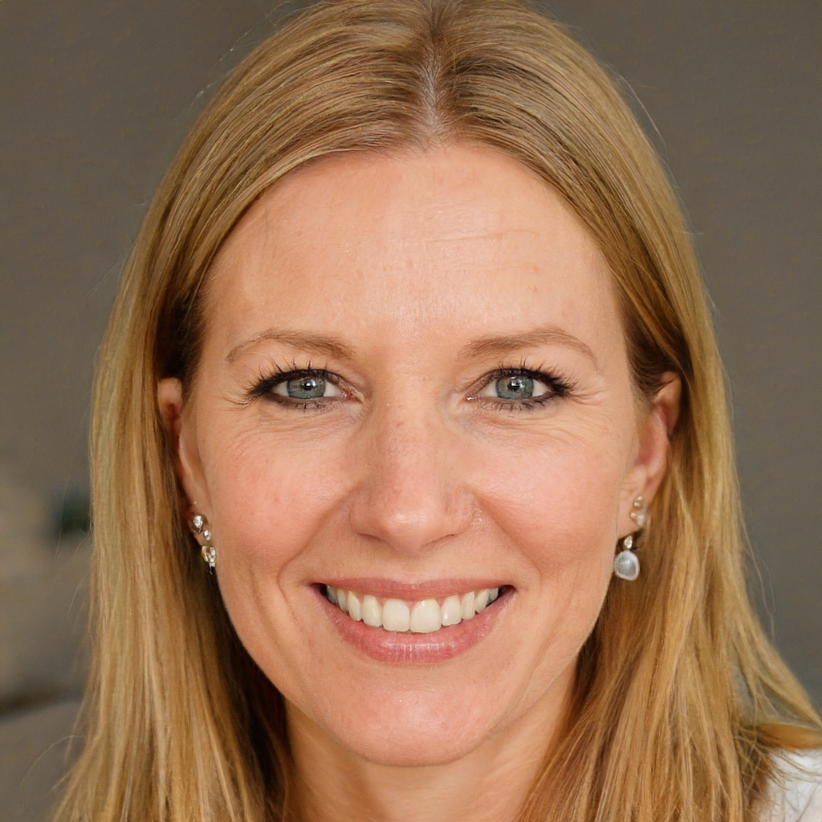

Female, age 49

Janet is a live-in caretaker for a differently abled individual. She spends a lot of her time at her patient’s house, and works odd hours.[1] She often remains at her patient’s house overnight. Her responsibilities also make it more difficult for Janet to relocate.[2] She and her family do not earn a lot of money, and she is near the top of the lower class.[3] Janet spends her time off work with her adult daughter, who she jointly takes care of with her husband. Janet uses her phone very often; she feels comfortable with apps on her phone.[4]

Janet in the Disaster

* *Emotional state:* In the wake of the natural disaster, Janet was left stranded in a damaged area for a long period of time.[5] Janet is in a lot of emotional distress; she is still in shock from what happened to her.[6] Janet feels anxious[7] and desperate to regain some control over her present situation.[8] Janet is now easily startled by loud noises, which remind her of what happened[9], and is more sensitive to negative stimuli.[10] The disaster left her surroundings completely upturned, and she has trouble navigating the once-familiar landscape of her city.
* *Memory and attention*: Janet managed to weather the disaster physically unharmed, but the stress is getting to her.[11] Janet is now easily distracted, and her thoughts tend to wonder. Janet’s short-term memory has taken a hit as well[12], which means that she has trouble remembering instructions and tasks. Being in a critical situation has made her risk-avoidant, and she prefers to take actions that minimize danger and cost.[13] Other than that, Janet has average information recall and planning ability.[14]
* *Attitudes towards Risk:* Janet is risk averse[15]; she makes decisions based on minimizing negative consequences, and she’s reluctant to attempt things the consequences of which she cannot guarantee or foresee.

Resource around Janet

* *Physical State*: Access to food and water in the wake of the natural disaster is limited, which means that Janet is not as well nourished as she should be.[16] As a result, Janet gets tired more easily, and is unable to perform strenuous activities for long periods of time.[17] This, combined with her aforementioned risk aversion, makes her unwilling to consider traveling far on foot. Janet has spent some time sleeping outside[18], which was not particularly restful; this further contributes to her fatigue. However, her fine motor skills remain sharp, and she is able to perform complicated tasks without difficulty.[19]
* *Access to Utilities:* Janet is without reliable access to electricity[20], internet[21], or radio[22]. Not only is she reluctant to use her phone for extended periods of time, but having to perform tasks repetitively may incur the cost of battery life, and thus have more serious consequences than normal. Services that require network connectivity will not work for Janet in almost all situations. However, GPS still works on her devices, as it is based on satellite data.

Janet’s Support Network

* *Community/Network:* When she is not staying at her patient’s house, Janet’s daughter lives with her.[23] Naturally, Janet is not only interested in her own well-being, but also that of her family. Aside from her daughter, Jaent’s support network during the natural disaster involves a neighbor with a pickup truck.[24] Although she has extended family, they do not live close, and she is unable to get in touch with them due to the lack of cell service. Despite this, Janet doesn’t personally know anyone who can provide shelter for her, so she is still on the search for good samaritans or generous individuals to get help.[25]

Mainstreamer: James

James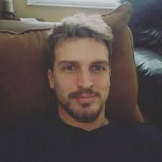

Male, age 35

James is on a business trip for work and he is a veteran. He has a family who lives inside of the affected area. His years of military service have prepared him for tough situations. Though he doesn’t like relying on it too much, he is comfortable with his smartphone, which he usually carries with him throughout his day.

Upbringings - Rural upbringing

Free Time Usage - Game Hunter, Outdoorsy

James in (or out of) the Disaster

James is not physically affected by the natural disaster; he remains in an area that was not in the disaster’s range. Although he is worried about his family in the affected area, he is not afraid for his life, nor suffering from symptoms of PTSD, nor anxious to the same extent as survivors of the natural disaster. Though he is stressed, his cognitive abilities are not affected by the unfolding events. His attention and memory thus vary between average and above average. He is able to recall information and plan with no difficulties.

James has no aversion to taking risks. Being affected by the natural disaster he is worried, but willing to take action if it may help him find his family.

Resources around James

Not being directly affected by the natural disaster, James has access to all utilities such as water, electricity, internet and cell services. This means he is able to use and call as much as he wants using his cellphone.

James is in good physical shape, and is well-nourished. He is able to perform prolonged and strenuous activities, and his outdoorsy hobbies make him slightly more apt than the average person. He also has no trouble with fine motor skills, and is able to use small or delicate devices (such as smartphones) with no difficulty.

James’ Support Network

James has family in the affected area that he is unable to reach. He can, however, reach neighbors and extended family who, although they live fairly far away from his area, are willing to travel to help him or his family cope with the situation.

Sources

1. Explore Health Careers. Date Accessed: 11/01/21. <https://explorehealthcareers.org/career/allied-health-professions/home-care-assistant-aide/>
2. United Nations. Date Accessed: 11/01/21. <https://www.un.org/press/en/2019/soc4876.doc.htm>
3. Flood Factor. Date Accessed: 11/01/21. [https://help.floodfactor.com/hc/en-us/articles/360048265533-How-will-different-flood-depths-affect-my-property](https://help.floodfactor.com/hc/en-us/articles/360048265533-How-will-different-flood-depths-affect-my-property-)
4. Federal Emergency Management Agency. Date Accessed: 11/01/21. <https://snmapmod.snco.us/fmm/document/fema-flood-zone-definitions.pdf>
5. Our World in Data. Date Accessed: 11/01/21. <https://ourworldindata.org/grapher/natural-disasters-by-type>
6. Steven Reinberg. <https://www.webmd.com/alzheimers/news/20180713/1-in-9-us-adults-over-45-reports-memory-issues>
7. Douglas MacMillan and Will Englund. <https://www.washingtonpost.com/business/2021/10/24/climate-change-power-outages/>
8. Climate Central. <https://medialibrary.climatecentral.org/resources/power-outages>
9. Federal Emergency Management Agency. Date Accessed: 11/01/21. <https://www.fema.gov/press-release/20210124/feeling-fatigue-due-disasters>
10. National Weather Service. Date Accessed: 11/01/21. <https://www.weather.gov/pbz/floods>
11. The Power Of Water. Date Accessed: 11/01/21. [Interview with a Katrina Survivor](https://thepowerofwaterg7.weebly.com/interview-with-a-hurricane-katrina-survivor.html)
12. Blanche Jewell, Myrna Matherne, Mary Price, Jennifer Abraham, Betty Wooddy, Angie Juban.Date Accessed: 11/01/21. [Voices in the Storm: Hurricane Katrina Survivors in Pointe Coupee Parish | LSU Libraries](https://www.lib.lsu.edu/oralhistory/collections/voicesinthestorm)
13. Australian Mental Health Commission. Date Accessed: 11/01/21. [Our Stories Beyond the Disaster](https://www.mentalhealthcommission.gov.au/getmedia/5221a681-0530-475b-8396-c8fc51c1ac3d/Our-Stories-Beyond-the-Disaster-Research-Report)
14. Vangimalla Reddy, Mura Jyostna Devi, and Venkatachalam Anbumozhi. Date Accessed: 11/01/21. <https://www.eria.org/uploads/media/Books/2019-Towards-a-Resilient-ASEAN-Vol1/15_Disaster-Climate-change-vol.1-Chapter-11.pdf>
15. Pan American Health Organization. Date Accessed: 11/01/21. <https://www.paho.org/en/health-emergencies/food-and-nutrition-disasters>
16. Rong Gong-Lin II. Date Accessed: 11/01/21. <https://www.latimes.com/california/story/2019-12-12/how-the-next-big-earthquake-will-worsen-mental-health>
17. Christine Vestal. Date Accessed: 11/01/21. <https://www.politico.com/agenda/story/2017/10/12/psychological-toll-natural-disasters-000547/>
18. Brigitte Osterath. Date Accessed: 11/01/21. <https://www.dw.com/en/how-the-body-copes-with-hunger/a-15478749>
19. National Coalition for the Homeless. Date Accessed: 11/01/21. <https://nationalhomeless.org/wp-content/uploads/2017/09/Natural-Disasters-and-Homelessness-Fact-Sheet-2009.pdf>
20. Thomas Frank. Date Accessed: 11/01/21. <https://www.scientificamerican.com/article/flooding-disproportionately-harms-black-neighborhoods/>
21. Bill Quigley. Date Accessed: 11/01/21. <https://web.archive.org/web/20061009215031/http://www.commondreams.org/views06/0221-36.htm>
22. Richard Fry, Jeffrey Passel and D’vera Cohn. Date Accessed: 11/01/21. [52% of young adults in US are living with their parents amid COVID-19 | Pew Research Center](https://www.pewresearch.org/fact-tank/2020/09/04/a-majority-of-young-adults-in-the-u-s-live-with-their-parents-for-the-first-time-since-the-great-depression/)
23. Bradford H. Gray and Kathy Hebert. Date Accessed: 11/01/21. <https://www.urban.org/sites/default/files/publication/50896/411348-Hospitals-in-Hurricane-Katrina.PDF>
24. S. O'Dea. Date Accessed: 11/01/21. <https://www.statista.com/statistics/489255/percentage-of-us-smartphone-owners-by-age-group/>
25. Statista Research Department. Date Accessed: 11/01/21. <https://www.statista.com/statistics/478777/smartphone-use-frequency-us-by-age/>
26. Heather McCullough. Date Accessed: 11/01/21. <https://pubs.er.usgs.gov/publication/70114624>
27. Matthew Tull. Date Accessed: 11/01/21. <https://www.verywellmind.com/ptsd-and-hurricane-katrina-2797190>
28. American Psychology Association. Date Accessed: 11/01/21. <https://www.apa.org/topics/disasters-response/recovering>
29. Oliver J. Robinson, Katherine Vytal, Brian R. Cornwell, and Christian Grillon. Date Accessed: 11/01/21. <https://www.ncbi.nlm.nih.gov/pmc/articles/PMC3656338/>
30. <https://www.mayoclinic.org/diseases-conditions/post-traumatic-stress-disorder/symptoms-causes/syc-20355967>
31. The Center for Disaster Philanthropy. Date Accessed: 11/01/21. 11/01/21.<https://disasterphilanthropy.org/issue-insight/nutrition/>
32. Tirivangasi HM<https://www.ncbi.nlm.nih.gov/pmc/articles/PMC6014128/>
33. John R. Freedy, M.D., PH.D., and William M. Simpson, JR. M.D Date Accessed: 11/01/21. <https://www.aafp.org/afp/2007/0315/p841.html>
34. Wikipedia Date Accessed: 11/01/21 <https://en.wikipedia.org/wiki/2010_Haiti_earthquake>
35. [Sandra K Hunter](https://pubmed.ncbi.nlm.nih.gov/?term=Hunter+SK&cauthor_id=27516536), [Hugo M Pereira](https://pubmed.ncbi.nlm.nih.gov/?term=Pereira+HM&cauthor_id=27516536), [Kevin G Keenan](https://pubmed.ncbi.nlm.nih.gov/?term=Keenan+KG&cauthor_id=27516536). Date Accessed: 11/01/21. <https://pubmed.ncbi.nlm.nih.gov/27516536/>
36. Abc10, Date Accessed: 11/01/21 <https://www.abc10.com/article/weather/earthquakes/earthquake-ready-or-not-what-can-happen-to-our-power-grids-after-an-earthquake/103-e51c518c-05dc-424b-b0df-8f31abb5813c>
37. Stephen Lawson. Date Accessed: 11/01/21. <https://www.networkworld.com/article/2313860/cell-carriers-tackle-katrina-damage.html>
38. Greg Marshall. Date Accessed: 11/01/21. [How People With Disabilities Weather Natural Disasters | Sierra Club](https://www.sierraclub.org/sierra/how-people-disabilities-weather-natural-disasters)
39. [Louise F. Pendry and Jessica Salvatore](https://www.sciencedirect.com/science/article/pii/S074756321500268X#!). Date Accessed: 11/01/21. [Individual and social benefits of online discussion forums - ScienceDirect](https://www.sciencedirect.com/science/article/pii/S074756321500268X)
40. [Ivy Wigmore](https://www.techtarget.com/contributor/Ivy-Wigmore). Date Accessed: 12/06/21.  [What is intermittent reinforcement? - Definition from WhatIs.com (techtarget.com)](https://whatis.techtarget.com/definition/intermittent-reinforcement)
41. Date Accessed: 12/06/21. <https://www.alleydog.com/glossary/definition.php?term=Intermittent+Reinforcement>

Facets

* Mental State
* Memory/Attention
* Physical State
* Attitude towards Risk
* Community/Network
* Access to Utilities

xMag Method: Heuristic Evaluation

Our group would like to use an approach based on the heuristic evaluation. We’d like to build on top of Neilsen’s 10 heuristics and provide our own heuristics in addition.

**Note:** we initially thought we needed to explain every heuristic, including ones that were not violated, for every screen. However, Dr. Burnett mentioned that we may only list heuristics that were violated and required fixes. Rather than deleting some of our original work explaining the “good” heuristics, we marked them with a green checkmark (**✓**). The work after Dr. Burnett’s email will not include explanations of the non-violated heuristics, but it will include their names and the checkmark.

Heuristics

*Offline Tolerance:* The interface should work well without access to the internet, or in spotty internet connections. User actions should not be interrupted by changing network connections, and actions performed while the application is disconnected should not be “swallowed” / ignored.

* Jameses tend to have reliable and consistent access to the internet. However, even in their case, various issues (malfunctioning phone, tunnel, large concrete building, or even a solar flare) can interrupt service.
* Janets do not have a reliable internet connection if they have any at all. This may last for long periods of time and occur even during critical situations. Thus, an application that relies too much on the internet is nigh-useless to a Janet.

*Power Economy:* The interface should behave in ways that prevent the user from wasting their device’s power. “Expensive” actions (long computations, use of hardware such as Bluetooth or GPS), should be clearly indicated, and their relative “hunger” for power should be delineated. Additionally, the interface should guide users towards behaviors that are equally economical (like the opposite of “dark patterns” that capture and retain users’ attention for long periods of time).

* Jameses tend to have plentiful access to electricity, but preserving power would not harm them, and nor would indicating when they are using more power than usual.
* For Janets, access to electricity may be severely limited. A wasteful application would thus quickly exhaust their power supply, and not only cease being useful but also prevent them from accessing other features of their device.

*Calm Computing*: It's important not to divert the user's attention away from the task at hand. By default, there should be nothing on a screen that they don't need to see, be it additional information or a distraction. In order to keep the user's focus, the application should include enough white space and logical layouts.

* Jameses in our situation may be to some degree distressed. Although they have not personally lived through a cataclysm, they may be worried about their loved ones in the affected area.
* During the natural disaster, Janet is in a lot of emotional distress. She feels anxious and desperate to regain some control over her present situation.

*Memory and Attention*: Different users have different relative mental processing abilities.

* Jameses tend to have average (or even above average) information processing ability.
* Janets have average information recall and planning ability. However, their recent stress and anxiety make it harder for them to remember instructions and tasks.

Individuals with weaker mental processing may benefit from a minimalist interface since it reduces cognitive overload. At the same time, such an interface does not work *worse* for individuals with good mental processing abilities. The application should avoid relying on context or previous (especially hidden) state. Reminders and tooltips can be used to make common tasks more user-friendly and require less recall.

*Physical Simplicity*: The application should not require complicated interactions from the user (e.g. multi-touch gestures, small tap targets), and should make it simple to recover in case the user does perform an incorrect action. Finally, the application should not require a high degree of precision from the user.

* Janets may be injured in various ways which will limit their ability to perform tasks in the application. Superficial cuts[26] may rule out the use of certain fingers, making multi-touch interaction more difficult. Other injuries to the arms may reduce coordination[27], as might head trauma.
* Although Jameses are not injured and tend to be in good physical condition, having simpler inputs will not be detrimental to them; they will simply have an easier time using the application.

*Attitude Towards Risk*: Risk taking differs between Janets and Jameses. The application should clearly communicate to the users the dangers of each action. Additionally, the application should be clear about the *benefits* of each action, to help cautious users accomplish their tasks with confidence.

* Janets tend to be at least somewhat panicked and anxious. These emotional states make them significantly more risk averse; they will be very cautious in their decision making. They may be unwilling to take actions the effects of which they cannot clearly foresee, or that they perceive as dangerous. Additionally, the unpredictable situation during a natural disaster presents many dangers, and users need to be informed of them as well as possible.

In addition to being motivated by our own Risk facet, we believe that due to the short-notice nature of some natural disasters, *anyone* might be in our target population. As such, the Tims and Abbies (from Gendermag) would be represented in our target population similarly to how they would be elsewhere. Tims and Abbeys too have different attitudes towards risk, which makes this heuristic all the more useful.

*Communication and Collaboration:* Whenever possible, the software needs to provide ways for multiple users to collaborate and share information.

* Depending on the type of Natural Disasters, Janets may lack access to family members or other community members.[28] Furthermore, access to other people, be it family or community members, increases the chances of positive outcomes after the natural disaster. Thus, by facilitating communication with others, the software will improve the situation for our underserved population.
* James are typically well-connected and have access to their family network. However, they would still benefit from the *addition* of shared / community resources (a mainstream example of this is *forums[29]*, where users are able to share experiences and hold discussion

#### 

Heuristic Evaluation

Overall Fixes and Improvements

Neilsen’s Aesthetic and Minimal Design:

* The white navigation bar has a low contrast to the rest of the application, and kind of seems empty. It would be good if it was some other color, so that it can be easily distinguishable from the rest of the application.

**Completed fix:** Change navigation bar to match the buttons’ primary colors. This is visible on every screen; however, this is a late change and we can’t update all the screenshots above; the screen now looks like this (note top bar color only):

Help and Documentation / Attitude towards Risk:

* We don’t have tooltips or help menus to explain to the user what to do. A user that’s just beginning to use our application may be concerned about pressing various buttons because they don’t know what they’ll do, or if they’ll cause anything destructive. This is especially a problem for our underserved population, who are more risk averse.

**Planned fix:** in the future, consider a “hint overlay” mode of teaching, where on first use, the application displays hints near important button elements to encourage the user to press them and to understand what they do. This is not applied for two reasons: tooltips for every UI element are a *lot* of additional design work (every screen needs extra stuff!) and it’s not clear that this is ideal (tips may prevent users from immediately getting what they want, which would go against our *Calm Computing* heuristic).

Physical Simplicity:

* The “down” and “up” arrows on the various banners are too hard to hit (they are on the map screen, which makes them part of this particular evaluation). Users who have poor coordination for any reason would have trouble pressing the buttons, and instead tap on the banner, which would take them to updates. This is not at all where they want to go, so it needs to be fixed

**Completed fix:** Increase the bounding box of the down/up buttons (scaled up more than 3 times). See the main map screen, as well as all other screens where banners are present (many of them).

Attitudes Towards Risk:

* The shelter list doesn’t make it clear which data is from the internet (this is possible if users have intermittent internet access, or if data from the servers “propagated” peer-to-peer to reach them) and which data is 100% crowdsourced. The crowdsourced data presents more of a risk (inaccuracies etc), and we need to make it clear to our users that this is the case.

**Completed fix:** mark “server-sourced” shelters with a “verified’ checkmark a la Twitter. This should make it clear that such shelters were not made up by potentially malicious individuals, but were recommended by some authority. The “verified” icon shows up anywhere a shelter is listed, and the “shelter details” view contains an explanation of what “verified” means, including that verified shelters can still be bad (e.g. in our example, the Convention Center is an “official” shelter, but the conditions are bad, so it has low reviews).

Memory and Attention:

* The icons listed on the shelter information are confusing. They are greyed out but it’s not clear what this means. Overall, it’s not easy to see what is actually present in a shelter and what isn’t.

**Completed fix:** split the icons into two rows, “available” and “not available”. This way, the user has less guesswork to do (“does grey mean it’s not there?”) and can pretty much just read off what the popup / list item says to get a clear idea of what’s there.

Heuristic Evaluation: Main Screen (used by several use cases)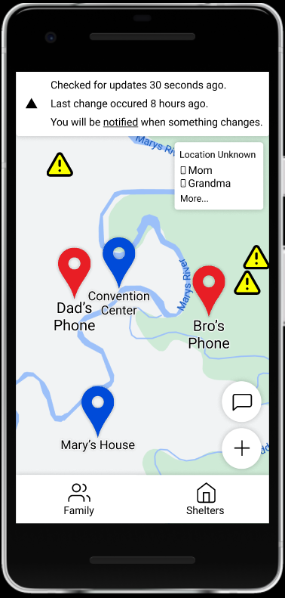

Nielsen’s:

**Visibility of system status ✘**

The navigation banner at the top of the screen clearly shows to the user when the data was last updated. The users can clearly see that they are on a map. We could do better by including an icon for internet access or lack thereof, but this might clash with *Minimalist Design*, *Memory and attention,* or *Calm Computing,* since it would be overwhelming to the user.

Fix: Jointly with our “risk” heuristic, we ended up adding the “no internet” icon as a warning to make it clear to users that information may be partial or incomplete.

**Match between system and the real world✓**

We are using the system language (thus, the user will not have to read English if they don’t know it). Complicated words are not used anywhere on this screen, and icons all have an established meaning. Yellow is used to communicate danger, which is commonly used in other contexts like road signs or error messages.

**User control and freedom✓**

Although the user cannot dismiss the last checked banner (specifically in order to prevent them from overusing the application according to our *Battery Efficiency* heuristic), they can make it smaller if they want. This is the top level of the screen, so there is nowhere to go back; there is thus no need for a back button.

**Consistency and standards✓**

All of the words and icons used in this application are standard. There are no words that have dual or ambiguous meanings. The application is *externally* consistent with Google Maps and Apple Maps by providing a similar interface, including pins and warning messages.

**Error prevention✓**

The user cannot do anything on the screen that would cause a *change*, and they can easily get out of any menu they open.

**Recognition rather than recall✓**

Users seeing the “Family” button may be more likely to click that rather than the “more” button on the list of unknown family members. Thus, instead of being presented with a list of family members whose location is unknown, they would be presented with a list of all family members. We believe no change is necessary here, since either way they would be able to see the unknown family members, and since we’d rather provide redundancy instead of forcing the users into one particular behavior. To make users more prone to tapping “More…”, we may gently pulse that menu, giving them an in-context hint of what to do next. However, this may send mixed signals (did this list just update?)

**Flexibility and efficiency of use ✓**

This screen contains a “pinned directions” button once the user pinned some directions. This means that a user can take a shortcut through the application to arrive at the directions they saved. Also ,the “Locations Unknown” list is another “shortcut”, where a user may immediately see the list of *unknown* family members and not have to look through the entire “family” list.

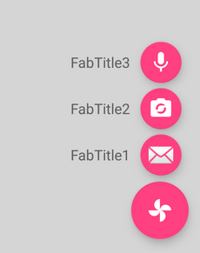

**Aesthetic and minimalist design ✓**

The number of buttons is a little bit large here, and would get even larger if we were to add various things like an SOS button or even a settings menu. Whereas this heuristic is not currently violated, it will likely be violated with the addition of new use cases and possibilities to the application. One potential solution is to place some actions into an expanding floating button (picture on the right), but this may make it harder for users to discover certain actions.

**Help users recognize, diagnose, and recover from errors ✘**

No errors are possible on the screen under the prior assumptions that the user has already correctly set up a family circle. If the user has set up a meeting point incorrectly, this point is visible, in a different color and with a tooltip text (“meeting point”) on the screen. Until this evaluation, there was no way to *unset* the point.

Fix: tapping the meeting point, a user can now unset it with the “unset meeting point” button.

**Help and documentation ✓**

The map screen has no tutorials. Although it’s possible to walk the user through what they can do from the map, we choose not to include it, because we want our user to be able to get access to their goals as quickly as possible (flexibility and ease of use). One possible idea is to include a question mark button somewhere on the map, where the user can press to receive help. However, on this particular screen, this is difficult due to the already-cluttered button palette on the right.

Our own:

**Offline tolerance ✓**

The map shows all available information, even if the internet is not available. It does not require the internet to function.

**Battery efficiency ✘**

The map includes a “last updated” banner meant to discourage users from repeatedly checking it for updates, and thus wasting more battery than necessary. Since the map is not immediately giving directions, it does not need precise GPS locations (which would be battery-consuming to acquire).

However, we may not have enough battery reminders in the application. These show up in “directions”, as well as in GPS navigation, but not on the main screen. If the user spends a long time browsing shelters, they can still exhaust their battery.

Fix:Add a battery indicator to the top left of the main screen if the user has spent a long time there. This indicator will be yellow and thus draw attention, but not be so large as to be prohibitive. Tapping it would bring up a popup describing the importance of power in a critical situation. Also add this icon to the “next turn” (navigating) screen, which was missing it.

**Calm computing ✓**

There’s a delicate balance here between preventing actions that are dangerous to users and not worrying them. The map *does* avoid overwhelming the user with information: it doesn’t present the details of each family member and shelter unless asked, and it only displays important information to the user. However, the warning markers could be considered extraneous and overwhelming. Nevertheless, we believe that including the warning markers helps users making dangerous decisions (choosing to go to an area that has been flooded, for example); we don’t want this information to be hidden under a layer, so that users have immediate access to it.

**Physical Simplicity ✓**

The map only requires two types of actions: drag and tap. The drag helps move around the map, and the tap is used to select various interactive parts. All the tap targets are large: the expand/hide button of the top banner has been deliberately made larger, and all the floating action buttons are bigger than a user’s fingertip. The same is true for the location markers, and the “Family” and “Shelters” button below.

**Memory and Attention ✓**

The user doesn’t need to remember anything about the state of the system to use the map. They can see the markers, and they can revisit them if necessary. Each marker is labeled with the name of the shelter / person it represents, so that users do not need to interact with it to see who it is. Buttons are labeled with icons that have established real-world meaning.

**Attitude Towards Risk ✘**

Risk-averse users are clearly given reports of errors that are available to the application. There are two potential issues here:

1. The error report is not significant (e. g., a broken stairstep *may* be reported by a peer, and would show up as a warning, but should not be enough to discourage the user from using a particular shelter if they are able to step over). In this case, risk-averse users may end up passing on shelters / locations that are superior to others. To cope with this issue, we allow users to tap both the shelter / user pins and the warning pins to get more information. We feel this is the best solution, since putting the “type of hazard” and “rating of shelter” on the main map for *every* shelter and warning would violate the *Calm Computing* and *Minimalist Design* heuristics.
2. The user is not aware that the reports are *not* complete. The information received within our application is inherently partial, and thus there may nevertheless be dangers next to a shelter that are *not* displayed on the map.

Fix: Add a “no internet connection” button after all, which brings up a popup explaining that information is received from other users and may be incomplete or out of date. This also addresses the earlier concern from “visibility of system status”.

**Communication and Collaboration ✓**

This screen contains a chat button at the tip of the user’s fingertips, which makes it simple for them to reach out to their family circle. In addition, the map aggregates information from other people, such as warnings and shelters (if this information is available, which is the most we can ask for), thus further helping users communicate.

Design Decisions

## Main Screen

The main screen is a combined map with both shelters and nearby family members. We made this decision based on Dr. Burnett’s suggestion; the combined view lets users make comprehensive decisions about what to do next. For instance, a user may notice that although a shelter is not the closest to where they are, it *is* closest to most other family members, and decide that they should meet there. We want to support this kind of comprehensive decision making.

Many screens related to family members include the “last checked” banner. We are concerned about intermittent reinforcement: a random, non-guaranteed reward is more likely to cause a user to try again and again[30]. To nudge the user away from such repeated behavior (which may cause them to waste battery), we include a banner that mentions how long ago the information was last updated, and when the last change occurred. We also remind the user that they will be *notified* in the event that something changes.

In the first two design galleries, we were told that the application was “confrontational” and “overwhelming”. This is because a lot of text was shown to our users at once, and because they needed to take a lot of steps through the application to achieve their goal. For this reason, we present the map screen first (with information at a glance), and add the chat button to this screen, so that family communication can be reached in a single step.

Finally, based on our **Physical State** facet, we chose to make all the interactive buttons on the application very large. Our users may be injured, which would limit their movement and make it more difficult for them to perform complicated tasks. Our “large size” affects the round floating action buttons for chat and plus, as well as “family” and “shelters”. The entire “unknown family list” is clickable, too, to bring up a popup.

## User Marker Tap Screen

Here, we are following Dr. Burnett’s advice about progressively revealing information. This helps us support people whose ability to process information may be limited due to stress or shock (our **Emotional State** facet, as well as **Memory and Attention**). The map doesn’t show too much - only pins - but additional information is one tap away.

We allow the users to request more information from the application if they want, without forcing them to look at it. This popup is one example of such “initially hidden” information. We have a location, last seen time, and a “self-reported safe” status, all of which would clutter the view too much normally. This particular way of displaying information supports the depth-first approach of accessing information, where a user doesn’t care for *all* data, just data on a particular family member.

Finally, the “self-reported safe” marker together with the green checkmark on the person’s photo helps put our users at ease whenever possible. Janet is under a lot of stress, and feels very anxious (about her family, too, according to various survivor interviews); we want to help her not feel this way.

## Location Marker Tap Screen

We used the same ideas here as with the user location tap screen. This has seen an additional change since our initial prototype: whereas we originally wanted to use colors to represent icons that were / weren’t there, we were concerned about color blindness (which affects 1 in 12 men), and the icon size. We were concerned that we wouldn’t be able to make “resources present” visually distinct enough from “resource not present”. We thus split the icons into two rows, “available” and “not available”. This way, there’s no confusion about what can be found at each shelter.

We also went with using the star system because of its familiarity with our users from other services (Amazon, Google Maps, etc.).

Abrar noted that our “Directions” button didn’t look like a button, so we made sure it was highlighted and raised to communicate its interactivity.

We have deliberately made the “Directions” button big to make it easier for users to hit it (in accordance with our **Physical State** facet, according to which our target population may have various injuries to the head and extremities that may make it harder to use the phone).

Finally, we added the “verified” checkmark to shelters that are sourced from a trustworthy database on the internet. This checkmark can be used by Risk-averse users (c.f. our **Attitudes towards Risk** facet). Not all shelters will have this checkmark, but those that do (if information about them somehow traveled through the peer-to-peer network to our user), will be clearly indicated as such. This checkmark is separate from reviews, since an “official” shelter can still have bad conditions (for example, the Superdome during Katrina was noted to be a mess).

## 

## Unknown Family Member List

Although the family member list is truncated, we allow the users to access complete information by tapping it. We wanted to avoid cluttering the screen, while concurrently starting with a map (which in itself cannot accurately represent family members with unknown locations). Dr. Burnett suggested that the truncation of the family list can be supplemented with drag and drop (allowing users to show names they most care about); we went with this idea. The grey dashed line indicates “the fold” past which names are not visible on the map. This is so that users dragging-and-dropping can have a quick visual indication of what exactly they will accomplish.

We used the standard six-dot symbol for drag and drop on each element as an affordance. This also distinguishes this list from the click-only one on the main map screen; the users will be less inclined to try dragging on the map (which wouldn’t work), but more inclined to drag here.

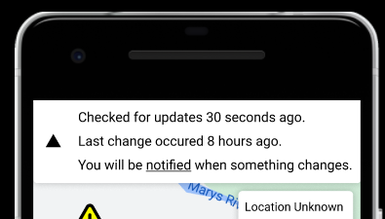

Collapsible Banners

To provide the users control, we allow the banners to be collapsible.This helps with the **Memory and Attention** facet: users who cannot hold as much information in their mind, and whose attention wanders, benefit from hiding the banner and getting some of the info out of sight. Although the user can’t completely remove the message, they can stow it away and free up more screen space.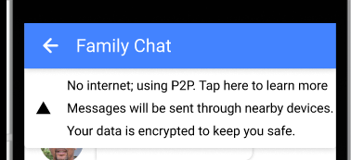

## Family Member List

This list presents the information that users can also receive from pins as a comprehensive list. However, this family member list also includes users whose locations are unknown, since we are now no longer forced (by virtue of our map format) to present them differently. To make it clear that their locations are unknown, we include question marks next to their name.

In addition to showing a family member list, we’ve added an extra button at the bottom to “look for others''. Through our **Community/Network** facet, we have gathered that survivors will have improved chances of long-term success if they have access to a strong network. As such, we want to allow them to increase their network, even if their family members are around or even with them,

Finally, this is the first of many screens with a navigation bar. This particular one has the words “Family Circle”, indicating to our users where they are. One of the feedback items we got during the last design gallery is that there is no way to navigate “back” through our application. We had initially made the assumption that phones will have a back button; however, this is not the case for iPhones and some other flavors of Android, so we ensured our users could backtrack by providing our own back button in the navigation bar. Although we initially made this navigation bar white, following our heuristic evaluation we switched it to blue to more clearly distinguish it from the rest of the page, and from the “last updated” banner.

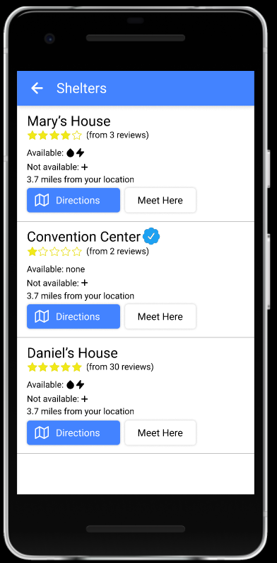

## Shelter List

The shelter list provides the same information as tapping a single shelter, but in a dense list. This way, users can browse through detailed information about all shelters at the same time, and make decisions while comparing different places they might choose to go. This makes it easier for users who don’t want to click pins one-by-one to understand their options.

Here you can see the “meet here” buttons for each shelter. These were also present in the map when a user tapped a single shelter. We added a confirmation dialog to these buttons, so that a user accidentally tapping “meet here” will not reset the family’s meating point to something they didn’t mean (this is motivated by Nielsen’s error prevention and recovery, as well as our own **Physical State** facet).

## Shelter Details

The shelter review page shows reviews written by other users. Users can get more information about the shelter and decide to go to the shelter or not. Every user can rate the shelter and write the review on any shelters from the list. We use stars for our rating system because stars are a common system for reporting an abstract “quality” of something, and stars are found in widely used services like Google or Apple Maps.

Our screen shows icons indicating what resources are available there, such as water, power, medical supplies. Our screen will also show which resources are absent from the shelter. The icons are colored in black if a resource is present, and colored red to make it more obvious that it’s absent. For users who cannot distinguish color, the resources are also grouped under “Resources Available” and “Resources Unavailable” tabs.

## 

## Navigation Method Selection

According to our **Access to Utilities** facet, we didn’t want our users to be wasting power, which in a natural disaster is a precious resource. For this reason, we gave them three options for navigation: writing directions down, memorizing directions, and using GPS.

After our Heuristic Evaluation from the previous assignment, we marked the “use GPS” button yellow to clearly communicate the risk (and included a battery icon to clearly communicate the reason for the risk). We also marked the “cost more battery” description red. This was motivated by the **Attitude towards Risk** facet, as well as Dr. Burnett’s remark that we should be very careful not to push our users towards endangering themselves.

## (Writing Down) Directions:

This is a pretty straightforward list-of-directions screen that can be scrolled. After our heuristic evaluation, we made the bottom navigation bar more clearly indicate the current tab (of which there are two). We also added a “pin” floating action button so that users may save directions for later. This helps if users want to exit the now-deep chain of actions (press directions, selected mode) and do something else (check on family etc.) Pinned directions are accessible from the map screen.

We added two different modes for directions because of Dr. Burnett’s mention of the different ways people navigate. Some people navigate by orienting themselves in space (for which we provide a map), while others prefer to follow instructions. We support both.

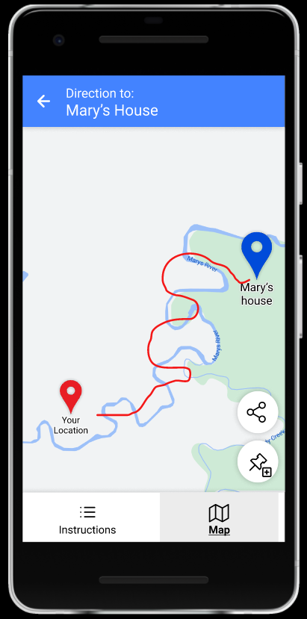

“Memorizing Directions”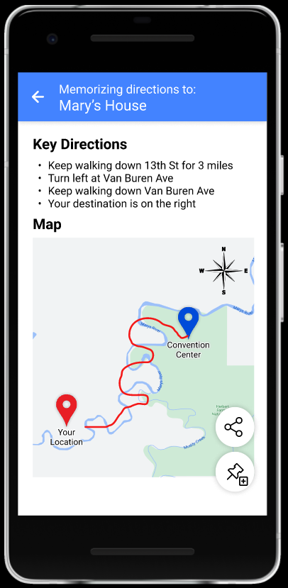

Originally, we intended to use something along the lines of a mnemonic device for this screen. However, during one of the design galleries, Abrar pointed out that this doesn’t sit well with our **Emotional State** facet; the kind of “light hearted” “tell-a-story-with-street-names” will likely not be well received by people in a state of panic and shock. Instead, we settled for condensed instructions (listing only important information about the route), as well as showing a bird’s eye view map.

Once again, the “pin” button is here to help users return to this screen from elsewhere.

Navigation Screen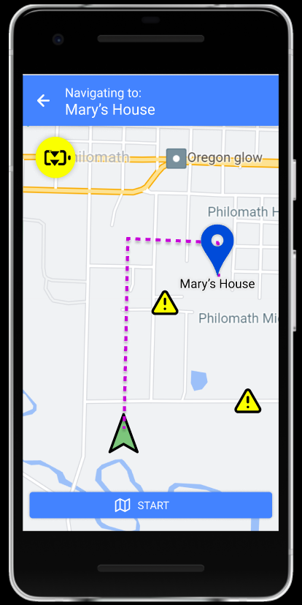

In this screen, we particularly wanted to mimic Google Maps to provide our users with external consistency for existing navigation solutions. We kept the map-related UI elements largely the same (blue pin for shelter, yellow triangle for danger). To remind the users of the excessive battery drain, we included the yellow “battery drain” icon to the top left (this is strongly based on our users’ **Access to Utilities** facet).

## Family Chat

Our application needs to support its own chat functionality because standard messaging services (SMS and IM) will likely not work or be overwhelmed (this is one of the main aspects of our **Access to Utilities** facet). Thus, we are allowing for the possibility of our application using Bluetooth to send data in a mesh / peer-to-peer fashion.

We wanted to make the family chat look familiar, so we didn’t invent anything particularly clever; the second button is on the right on left-to-right systems, and the various attachment buttons (only location in our case) are on the left to minimize the chance of misclicks (this once again works with our **Physical State** facet - we don’t want our users to *need* precise taps to use our application).

We want to make it clear to the users that this is happening, especially since messages sent via “nearby devices” may take significantly longer to arrive. Thus, we’ve added another collapsible banner (“no internet; using P2P”) when standard messaging protocols are not accessible. The expanded version of the popup (its initial state) also explains briefly that “peer to peer” means that messages will be sent using nearby phones. This warns our users of what they may consider to be a *risk* (this is important according to our **Attitude Towards Risk** facet).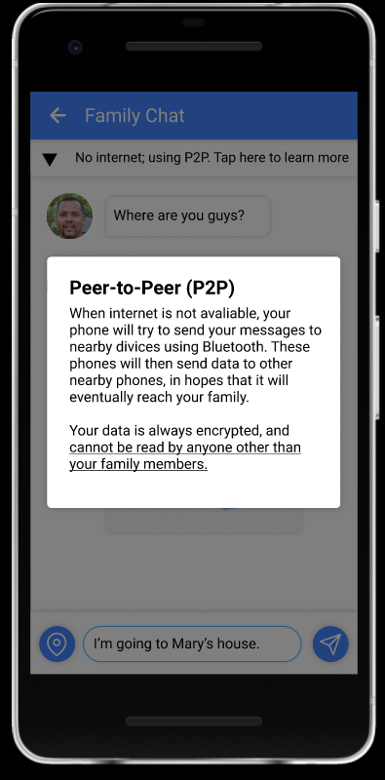

We want this information easily accessible (and we want to inform the users that messages are sent *through other devices*, as per the **Risk** facet). However, we also want to put our users at ease, letting them know that no unintended recipient will be able to read their messages. Tapping the banner brings up an informational message.

“Search for Others”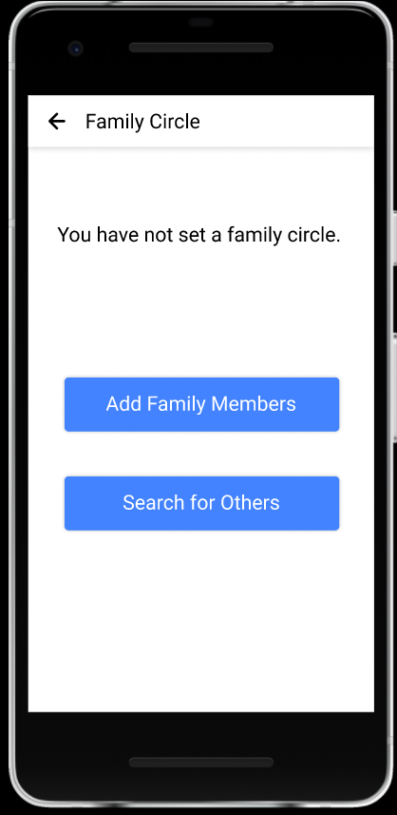

Our **Community/Network** facet indicates that some of our underserved population members may have no close family or friends, which also makes them much more vulnerable in a natural disaster. For this reason, we provided a specific screen for those who don’t have a family circle set, so that they are able to make contact with others even if they didn’t know anyone at first. We hope that this would help our underserved population weather the trying situation.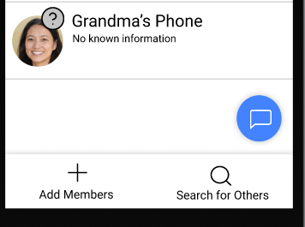

## Searching for Others Toggle

This screen is used to provide information to our user before they enable “find other people”. According to the **Attitude Towards Risk** facet, we wanted it to be clear to the user that they will be exposing their location to the world, but that this would also make it possible for them to find others who also want to team up. Thus, we made a whole separate screen for this toggle, and provided an explanation there to tell our users how things work.

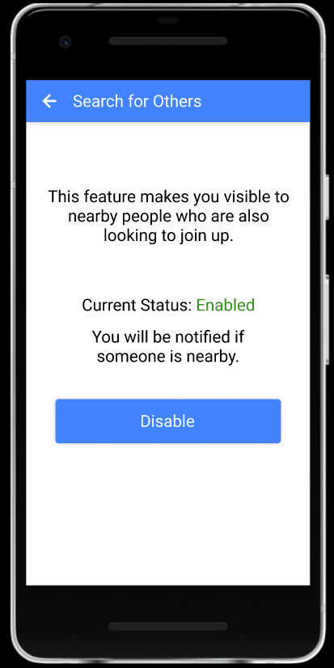

Heuristic Evaluation Template

Nielsen’s:

**Visibility of system status ✓✘**

**Match between system and the real world ✓✘**

**User control and freedom ✓✘**

**Consistency and standards ✓✘**

**Error prevention ✓✘**

**Recognition rather than recall ✓✘**

**Flexibility and efficiency of use ✓✘**

**Aesthetic and minimalist design ✓✘**

**Help users recognize, diagnose, and recover from errors ✓✘**

**Help and documentation ✓✘**

Our own:

**Offline tolerance ✓✘**

**Battery efficiency ✓✘**

**Calm computing ✓✘**

**Physical Simplicity ✓✘**

**Memory and Attention ✓✘**

**Attitude Towards Risk ✓✘**

**Communication and Collaboration ✓✘**

1. Many home care assistants work weekends and holidays, and remain with their patients overnight to provide specialized care. [Source 1].
2. Doctors and other healthcare professionals are at times forced to remain with patients that cannot be evacuated or moved prior to a natural disaster. [Source 23].
3. People who stayed in the disaster area were more likely with low income. [Source 12]
4. 95% of US adults aged 30-49 owned a smartphone in 2021 [Source 24]. In 2015, 59% of adults of this age reported using their phone at least once an hour. [Source 25].
5. The consequences of many of the most common natural disasters can last for many days. For example, floods can last a week or more [Source 10]; Some extreme weather can induce floods [Source 12]. In 2019, these made up 70% of all natural disasters. [Source 5]. After earthquakes and floods, transportation to and from the affected area can be severely limited [Source 26]. This greatly inhibits rescue and aid efforts, and makes it harder for survivors to leave.
6. Most survivors of natural disasters report feelings of fear and anxiety [Source 11, 12, 13]
7. See footnote 6.
8. People after natural disasters tend to experience a lack of control, and respond well to interventions that reaffirm their influence over their own life. [Source 13]
9. Among the symptoms of PTSD is a strong negative reaction to events that remind you of the traumatic event. [Source 30]
10. 1 in 4 earthquake survivors and 1 in 2 Katrina survivors experienced symptoms of PTSD [Source 16, 27]
11. See footnote 6; anxiety has negative effects on attention and spatial navigation, among other things. [Source 29].
12. See footnotes 6 and 11; in addition to anxiety and PTSD typically causing memory issues, some natural disasters have been associated with cognitive impairments. One example is Katrina brain, which too causes memory and attention issues. Interviews with some survivors point to similar afflictions [Source 17, 13]
13. Risk-avoidance is noted [Source 29] to be a symptom of anxiety and fear.
14. Long-term and working memory are not affected by non-pathological anxiety, which is the type of anxiety experienced by disaster survivors. [Source 29].
15. See footnote 13.
16. Floods, tsunamis and earthquakes can seriously impair food stores and distribution, which may lead to widespread hunger. In addition, consequences of natural disasters may make it more difficult for survivors to procure food. [Source 31, 32].
17. Hunger causes the body to break down muscle, and causes fatigue. [Source 18]
18. Homelessness rates spike during a natural disaster, even for people who are homeowners due to the destruction wrought by the cataclysm. For example, the Haiti earthquake of 2010 left 90% of the buildings in the area destroyed [Source 34].
19. Although age is associated with decline in physical abilities, this decline typically becomes more significant in old and very old adults (60+) [Source 35].
20. Earthquakes cause serious damage to power grids and therefore leave large areas without electricity. [Source 36]. Floods in high-risk areas can cause water to rise as high as 1-3 feet, which is enough to reach and disable electrical outlets, as well as generators. [Sources 3, 4]. Floodwater can also damage backup generators [Source 12].
21. Cell towers affected by storms or earthquakes can either malfunction due to lack of electricity (see footnote 19), or due to the lack of access to the larger network [Source 37]. During earthquakes, fiber-optic connectivity can be affected, causing wired internet connections to also be unavailable. [Source 34].
22. Radio equipment can malfunction due to lack of electricity or damage; during the Haiti earthquake of 2010, many radio stations were taken off the air for about a week [Source 34], and survivors of Katrina reported having no radio contact with the outside world [Source 12].
23. Over 50% of young adults live with parents in the US because of COVID. [Source 22]
24. From interviews, almost one third of the interviewers were helped by neighbors or friends. [Source 12]
25. In severe and destructive natural disasters, the government response is spread thin. Survivors often have to rely on the help of independent individuals or groups for rescue and aid. [Source 12, 34,
26. One of the most common injuries during Katrina; extreme weather itself is the second most common natural disaster. [Source 21 from Project Installment 3, and Source 5 from Project Installment 4]
27. Injuries to the extremities are common during many common types of natural disasters. [Source 21 from PI 3]
28. This is particularly significant during natural disasters with forewarning, in which vulnerable populations are much less likely to evacuate. [Source 38 above, Source 43 from PI 3]
29. Forums are found to have “benefits at individual and society level” [Source 39 above]
30. Intermittent reinforcement is a common technique used to keep the attention of people using gambling machines. [Source 40 above]. Being rewarded *sometimes* can be more behavior-forming than being rewarded *always*. [Souce 41 above]